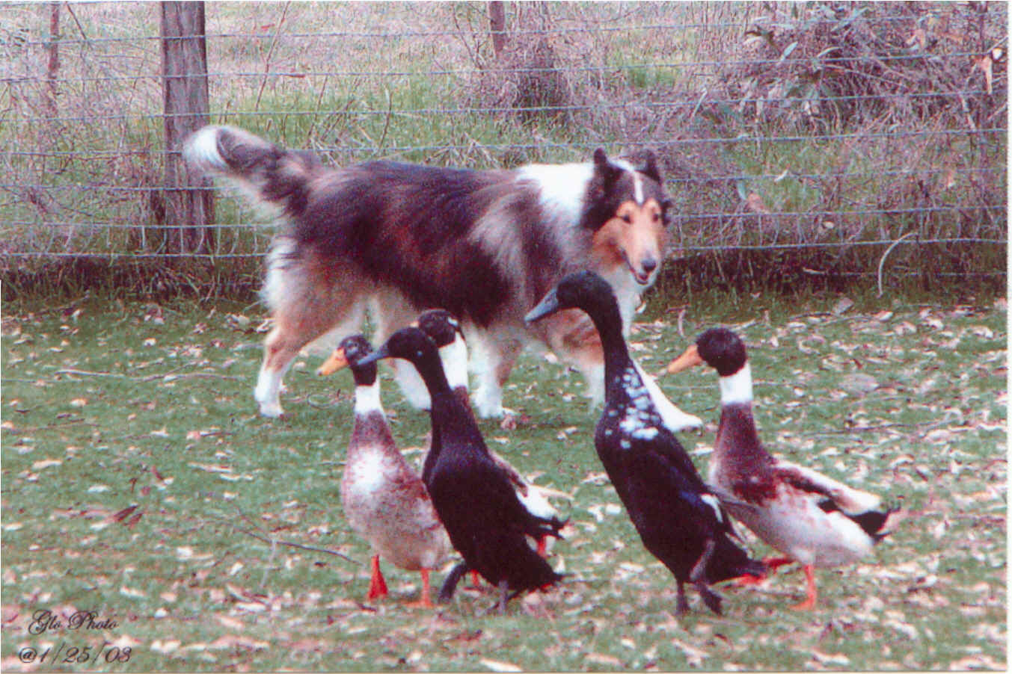
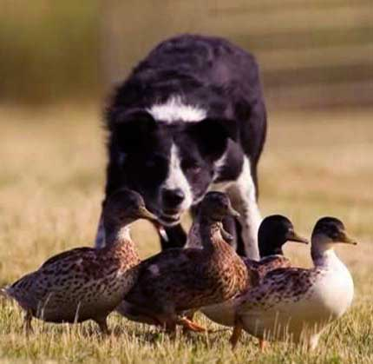
GREAT RIVER STOCK DOG CLUB

WINTER FUNDRAISER
2 AHBA DUCK TRIALS

January 25, 2014
Cure the winter blues with fun winter herding in an indoor arena!

LOCATION
Silver Wind Farm
17250 Marystown Rd
Shakopee, MN 55379

Entries limited to 24 per trial
$30/entry each dog
HTAD Course #1 Gather & Shed

AM trial judge : Susanne Hoffman
Start Time 8:00 am
PM trial judge: JoAnna Yund
Start Time approx 1 pm

Potluck lunch & GRSC Annual Meeting
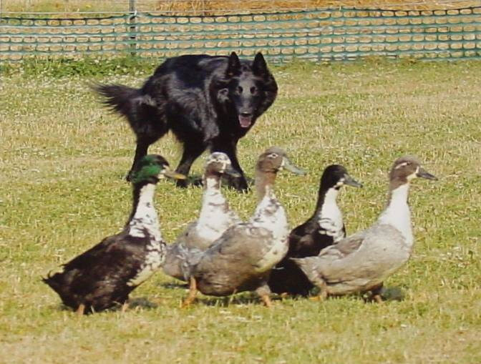
Approx. 11:30 am
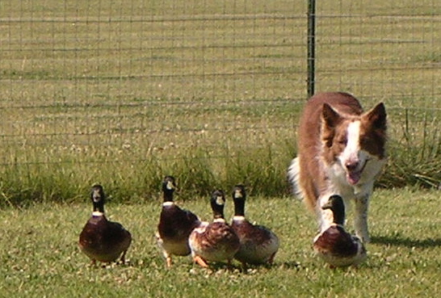
Trial secretary Julia Torgersen
5416 - 245th St.
Forest Lake, MN 55025
jrtsplash@midco.net

